


Topaz Arts Space Exploration Dance Residency
TOPAZ ARTS announces an open call for Dance in Queens 2012: Space Exploration Dance Residency. Taking place at the TOPAZ ARTS Studio in Woodside, NY in New York City’s borough of Queens, this artist residency focuses on contemporary dance makers, offering choreographers concentrated time and a private space in which to explore new ideas.

Up to six choreographers will be selected to receive free rehearsal space at TOPAZ ARTS.
Choreographers will each be awarded 30 hours during April to June 2012 (hours to be used within a one-month period) in the spacious 1,250 sq. ft. studio. The intent of this residency is to support concentrated time for the creation process, allowing choreographers a space in which to explore ideas or new working methods, with an opportunity to have informal open rehearsals or artist talks to discuss their creative process among peers and audiences.

Choreographers from all five boroughs of New York City may apply. Also open to artists outside of NYC, but please note: there is no stipend, no travel and no housing provided. Choreographers will be chosen from a competitive application process and reviewed by a panel of professionals in the dance field on the basis of artistic merit, description of intent for the residency and video work samples. Awardees will be announced by mid-March.

Studio location: TOPAZ ARTS, 55-03 39th Avenue, Woodside, Queens
Subway: #7 to 61 St/Woodside or R,M,E to Northern Blvd. > http://www.topazarts.org/directions/

DEADLINE: Fri, MARCH 9, 2012 (Must be received by 11:59pm EST)
Application form must be submitted by email to: topazartsresidency@gmail.com

Application form and information available at http://www.topazarts.org
For inquiries, please email: topazartsresidency@gmail.com

The Dance in Queens Residency Program is a project of TOPAZ ARTS initiated in Summer 2003 to provide opportunities for contemporary dance in the Queens community. Initially in partnership with the Queens Museum of Art, Dance in Queens 2012 takes place entirely at TOPAZ ARTS facility during the museum’s expansion.

TOPAZ ARTS, Inc. is a nonprofit arts organization founded in 2000 by artists Todd Richmond and Paz Tanjuaquio.
TOPAZ ARTS fosters new works and provides public programs for contemporary performance and visual arts. Providing a creative development center, TOPAZ ARTS offers affordable space, gallery exhibitions and residency opportunities, enabling artists to realize their projects and the process shared with audiences. An urban oasis designed using sustainable concepts, the 2,500 sq. ft. facility boasts a light-filled gallery space, a rehearsal studio with a heated dance floor, and an organic roof garden. For more info, please visit www.topazarts.org.
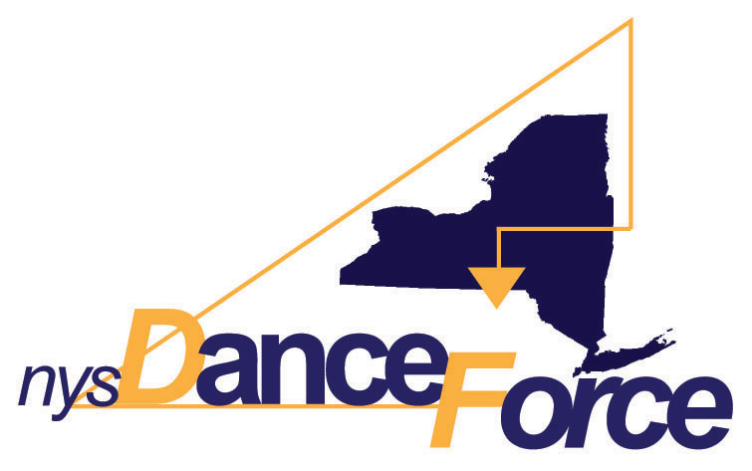

This project is supported by the New York State DanceForce with funding
from the New York State Council on the Arts Dance Program; and, in part,
by NYC Department of Cultural Affairs.
TOPAZ ARTS application form — Dance in Queens 2012: Space Exploration Dance Residency

CHOREOGRAPHER NAME:

ADDRESS:

CITY: STATE: ZIP CODE:

TELEPHONE: ALT#:

EMAIL: WEBSITE:

WORK Description: Briefly describe your work and your plans for the residency: (How do you intend to use your time. Will you be exploring new material or a new process? How many people are involved? etc.)
Please note: up to six participants only may be included in your rehearsals. (approx. 200 words)

Preferred Month: (indicate 1st, 2nd, or 3rd choice) April May JUNE

WORK SAMPLE: Please choose a video sample that best represents your current work. Up to 5 minutes viewed.
Check format: ONLINE (preferred): http://
mark (X) DVD: indicate chapter/start number:

Title of Work:
Performed at: Duration of Complete Work: Year:
Brief Description/Additional Credits: (please limit response to space provided)

PLEASE SUBMIT THE FOLLOWING as attachments by email to: topazartsresidency@gmail.com:
- Include the subject heading: SUBMISSIONS and attach this completed application form
- In the body of email, please include your current bio (you may attach a resume as pdf or doc)
- Include a link for your work sample (indicate URL only - do NOT send video files by email!)
- DVDs accepted by mail to: TOPAZ ARTS, Inc., PO Box 770150, Woodside, NY, 11377-0150.
(Only mail-in DVD if you do not have video samples online. All materials will NOT be returned.)

DEADLINE: Fri, MARCH 9, 2012 (Must be received by 11:59pm EST)
Application form must be submitted by email to: topazartsresidency@gmail.com

PRINT NAME: DATE:

